**QUAID-E-AZAM UNIVERSITY, ISLAMABAD**



**Assignment 1**

**Name:** Jamshaid Ahmed Anjum

**Dept.** BS COMP. SC. 5th SEM.

**Reg. No.** 04072113015

**Subject:** CS-414 V (AI)

**Submitted to:** Dr. Ayaz Hussain

**Date:** 10-Nov-2023

**Analysis of Results**

**Developed Linear Predictor vs. Built-in Predictor**

The performance of the developed linear predictor and the built-in predictor was evaluated on a task of detecting responses in chat messages. Both models were trained on a dataset of more than 100 examples, and their learning curves were analyzed and are discussed as following.

**Learning Curves**

**Built-in Linear Predictor:**

* The training error remained consistently below 0.10, showcasing a high accuracy of the model on the training set.
* The testing error, while slightly higher, stayed stable at 0.15 throughout the iterations, indicating good generalization.

**Developed Linear Predictor:**

* The learning curves for different step sizes (0.01, 0.1, 0.5, 1.0) showed distinct behaviors.
* A smaller learning rate (0.01) led to a slow decrease in loss, while larger rates (0.1, 0.5, 1.0) showed quicker convergence, with 1.0 reaching a plateau around 0.23 loss.

**Comparing Curves**

**Convergence and Accuracy**

* The built-in predictor converged quickly, maintaining low training and testing errors, suggesting a well-fitted model.
* In contrast, the self-developed predictor showed varying convergence rates based on the step size, with higher rates achieving faster convergence.

**Step Size Impact**

The impact of step size on the developed predictor was evident:

* Smaller step sizes (0.01) resulted in slow but consistent convergence.
* Moderate step sizes (0.1, 0.5) showed a balance between convergence speed and stability.
* Larger step size (1.0) achieved faster convergence but exhibited fluctuations.

**Challenges and Insights**

**Challenges**

* Ensuring convergence stability with varying step sizes posed a challenge.
* Fine-tuning step sizes to balance convergence speed without overshooting was crucial.

**Insights**

* The built-in predictor, being an optimized implementation, demonstrated stable and rapid convergence.
* Experimenting with step sizes provided insights into the trade-off between convergence speed and stability.

**Conclusion**

The built-in linear predictor showcased robust performance with quick and stable convergence. The self-developed predictor demonstrated flexibility in controlling convergence based on the chosen step size. Understanding the impact of step size is crucial for balancing convergence speed and stability. Overall, the predictors show promise in detecting responses in chat messages, with the built-in method providing a reliable benchmark. Further refinement and experimentation could enhance the self-developed predictor's performance.

**Visuals**

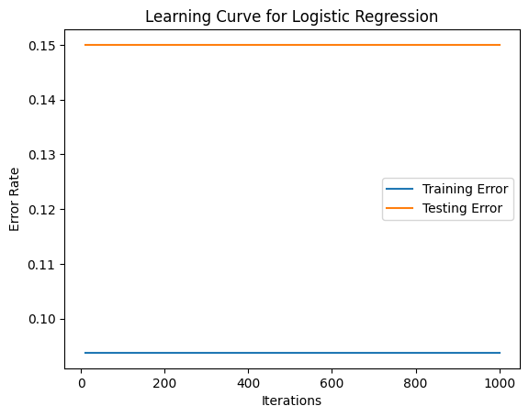

**Learning Curve for Built-in Linear Predictor**

**Learning Curves for Different Step Sizes (Developed Linear Predictor)**

[](BuiltInPredictor.py) [](SelfDevelopedPredictor.py)

**Click to open the files Please!!**

**BuiltInPredictor.py**

**SelfDevelopedPredictor.py**